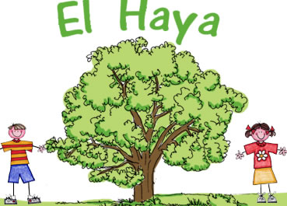
1. LOOK AND COMPLETE WITH ONE WORD

Description | letters | word
My hands are warm now! I put on my… | 6
Superman is very… | 6
The princess and the prince are… | 11
She is young and good-looking. Part of the Royal Family. | 8
Monkeys are… | 5
She can use magic | 5
A person who investigates the world. | 8
He is old. Part of the Royal Family. | 4
Batman is wearing a… | 4
He is 85 years old. He is… | 3
He has to obtain secret information. He’s very quiet. | 3
She is old. Part of the Royal Family | 5
He can play football. | 10
She is 8 years old. She is… | 5
He can use magic. | 6
A giraffe is very… | 4

2. LOOK AND COMPLETE

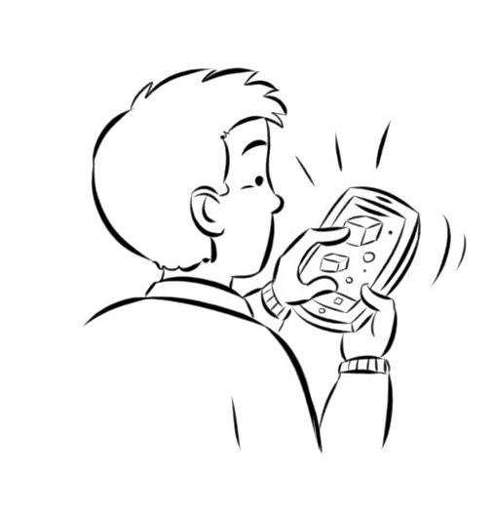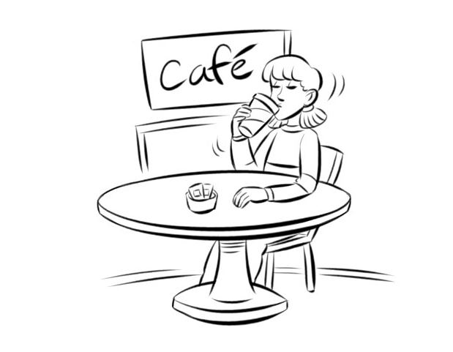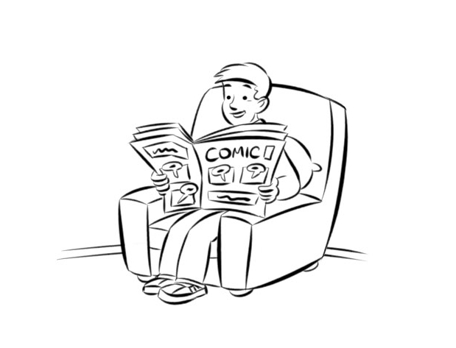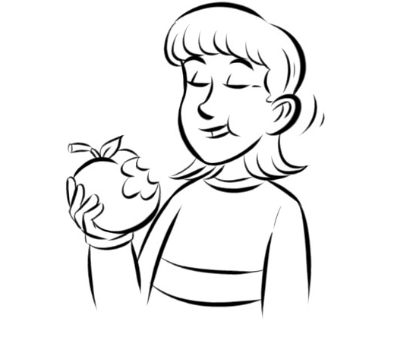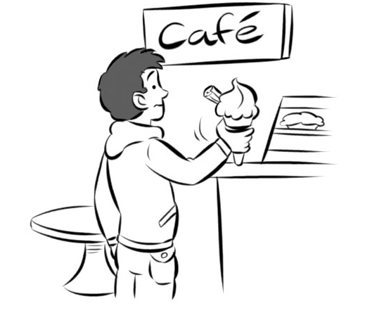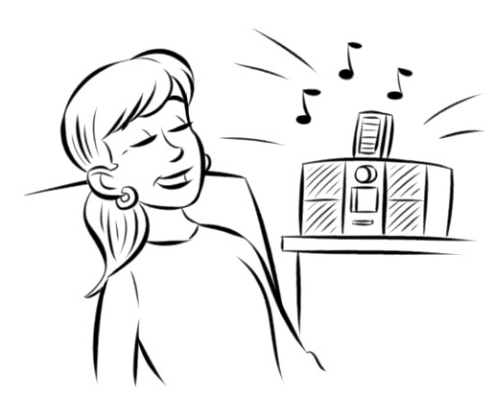
1
2
3
4
5
6

0 | He is playing football
1
2
3
4
5
6

